Email Communication Conventions

A Short Guide to Emailing

Version 1.4

November 15, 2005

Revision History
DateVersionDescription | Author
23/08/20051.0Created | Olena Derzhko
23/08/20051.1Proofread | Oksana Nyshta
14/09/20051.2Changes introduced | Olena Derzhko
21/11/20051.33.2.3 Section extended. | Olena Derzhko
10/11/20061.4Signature section updated | Andrew Ivashkiv

Table of contents

1 Introduction 4
1.1 Purpose 4
2 Think Before You Email 4
2.1 Consider Email Purpose 4
2.2 Addressing Email Message 4
2.3 Replying to Emails 5
2.3.1 Use Out of Office Assistant 5
3 Composing Email Message 7
3.1 Writing Subject Lines 7
3.2 Email Message Structure 8
3.2.1 Salutation 8
3.2.2 Message Body 9
3.2.3 Ending and Signature 10
3.2.3.1 Use the automatic signature 11
3.3 Relevant Language to Use 12
3.4 Formatting Email Message 14
3.4.1 Use spell checking option when composing email message 15
3.5 Sending Attachments with Care 17
4 Configuring Your Mail Account 17
5 Examples of Emails 18

Introduction

Purpose
This document is created to formalize the unique standards of email communication within SoftServe Company, providing necessary information on email usage. A clear understanding of the conventions should eliminate a number of questions and misunderstandings that may arise while emailing. By handling its email correspondence in synch with professional standards, SoftServe will gain yet another competitive edge in the industry.

The author expresses gratefulness and appreciation to English Department, especially to Tetyana Naychuk for cooperation and support in creating this document.

Think Before You Email

Consider Email Purpose
When writing an email adhere to the following rules: be polite, respect people’s privacy, keep the message simple, clearly identify the purpose of the message and action that you want the recipient to take after reading your message.

Addressing Email Message
It is important that you target your message to the appropriate audience.

The To line
Clearly identify the recipients of your email message. They should be the persons, who are directly requested to perform a certain action.
Agree the proper recipients of your email with your project manager, in case you are not sure they are the relevant ones.
When sending one email both to external recipient and to internal mail distribution group,
open the group to show all email addresses.
Otherwise external recipient will not be able to reply to mail addresses covered in mail distribution group.
Note
Open the mail distribution group reasonably to protect the mail addresses from spam.
The Cc line
Cc means carbon copy. Here, enter the address of anyone you would like to receive a copy of your email.
No action or response should be expected of individuals on the Cc line. The recipient only needs to read and/or file the message.
The Bcc line
Bcc means blind carbon copy. If you want to send a copy of your email to another addressee, without the original recipient’s awareness, put the address on the Bcc line.
Use your sound judgment on when to use this option, as there is a risk of the person in the Bcc line hitting the Reply All button, and unintentionally revealing his/her participation in the email correspondence.

Replying to Emails
Emails should be answered within at most 2 working hours. In rare cases when you cannot respond to the email within these 2 hours, send a reply informing the addressee of the time when he/she can expect your answer.
The priority emails must be answered immediately.

When answering email, make sure that you have dealt with every question raised by the sender. Do not omit any of them.

You are not expected to answer the email if you are in Cc list.

Use Out of Office Assistant
When you are out of the office, do not leave your associates wondering why you have not responded to their email messages. To avoid this, you should set up an automated reply to the messages you receive while you are out.
This easy-to-use feature requires you to have a Microsoft Exchange Server email account
In Mail, on the Tools menu, click Out of Office Assistant.
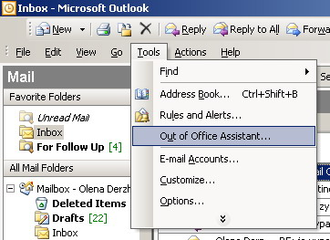
- Click I am currently Out of the Office.
- In the AutoReply only once to each sender with the following text box, type the message that you want to send to others while you are out.
Note In message you should indicate the relevant person to answer the required questions when you are away.
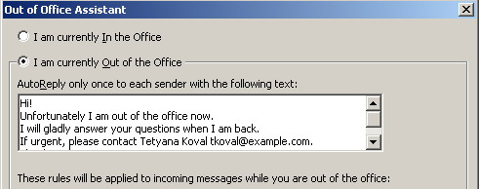
- If you want, create rules to manage your incoming mail. Here is how you can do this:
  - On the Tools menu, click Out of Office Assistant.
Note
The Out of Office Assistant command does not appear unless you are using an Exchange Server email account.
  - Click Add Rule.
  - Under When a message arrives that meets the following conditions, specify the conditions of the rule that the message must meet for the action to occur.
  - 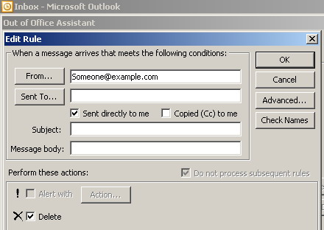
  - To specify more conditions, click Advanced, select the options that you want, and then click OK.
  - To specify that this rule must be the last one applied, select the Do not process subsequent rules check box.
  - Under Perform these actions, select the options that you want. You can select more than one option.
Note
If you specify that a message must be deleted, rules that follow the delete rule in the list of rules in the Out of Office Assistant dialog box do not affect the message.
Important
Use Out of Office Assistant in communicating only with special persons to protect your email address from spam.

Composing Email Message

Writing Subject Lines
The subject in email is mandatory.
Remember! The subject of your email should be meaningful to enable recipients to comprehend the subject matter easily and correctly.
Subject line should accurately summarize the body of the message. Therefore, the subject of email should be written only after the message was composed.
In case when the main project consists of many subprojects, the title of the main project should go first in Subject line, followed by the title of subproject. After that the topic of the email message should be written in the Subject line.
E.g.
SalesWork - 1215: proposal translation
SalesWork - 1115: fix delivery
Where 1215 and 1115 are titles of the subprojects, and serve the tracking purpose (read: are easy to locate) in the SalesWork email chain.
Try to restrict yourself to one subject per message
If your email contains multiple messages that are not closely related, it is better to break the issues into separate messages with proper subjects allowing your recipient to deal with each message individually.

Email Message Structure
While compiling an email message, follow the layout of the letter with its constituent parts. The main parts of the letter are the following ones:
- Salutation
- Message body that consists of the
- Introduction, in which we clearly state our reason for writing
- Main body, in which we develop our subject by introducing major points in separate paragraphs
- Final paragraph, in which we sum up what we’ve talked about, or we express our wish for something to be done by the recipient of the message
- Ending and Signature

Salutation
The salutation of your email massage can differ depending on the recipient’s status and the letter style – formal, neutral, or informal. Please see below for appropriate examples:
Formal style
Dear Sir/Madam if you do not know the name of the person you are writing to
Dear Gentlemen / Dear Sir or Madam if you are writing to a company
Dear Mr + surname -a title used to address a man
Dear Mrs. + surname – a title used to address a married woman
Dear Miss + surname – a title used to address a single woman
Dear Ms. + surname – a title used before a woman’s family name because it is not important to say whether she is married or not or when you do not know whether she is married or not. Many women prefer to be addressed as Ms. Rather than Mrs. or Miss. in business correspondence.
Neutral style
Dear + the unified attribute - if you are addressing a group of people. For example: Dear Project Managers, Dear Developers, Dear all, Dear everyone, Dear colleagues.
Informal style
Dear Tom, Hello everyone, Hi, Hello.

Message Body
Email message body covers the introduction, main body and final paragraph.
Introduction
In the introduction we clearly state the reason we are writing
I am writing to you (not I write you) with reference to/in connection with… я пишу стосовно
I am writing in response to your letter of 22 July regarding…
I am writing to inform you…
I am pleased to inform you that
I am writing to request your advice on a business matter
I am writing to enquire whether you could let me have some information about …
I would like to know…
I have received your letter of…
Thank you for your letter of…
In reply/in response to your letter у відповідь на Ваш лист
In confirmation of our telephone conversation I would like to inform you на підтвердження нашої телефонної розмови я б хотів повідомити Вас що...
I am sorry for the delay in answering your letter перепрошую за затримку з відповіддю
Main body
In the main body we develop our subject introducing each main point in a separate paragraph.
Final paragraph
In the final paragraph we sum up what we have talked about before, or we express our wish for something to be done
Could you, please, give me the details of …?
I would be grateful/ thankful if you could send me …
Please inform me about that (let me know this) in the shortest possible time/ asap
I would like to assure you that… хочу Вас запевнити, що
I am looking forward to receiving your consent (approval, confirmation) Чекаю Вашої згоди, схвалення, підтвердження
I am looking forward to hearing from you
If you gave some information in the letter, you can close:
I hope that this information will help you.
Please contact us if you have any questions.
Please feel free to contact me if you need any further information.
Please do not hesitate to let us know if you require any further information. (Formal)
Other expressions you might find useful:
You will find attached…
Please find attached…
Attached to this letter you will find…
Further information will be sent on…
Thank you so much for…
As requested by you...

Ending and Signature
If you begin a letter with Dear Mr./Mrs./Ms/Miss + surname you end with
Yours Sincerely.
If you start with Dear Sir/Madam you end with Yours truly/Yours faithfully.
If you use Dear, Hi, Hello, you end with Best regards, Regards, Best wishes, All the best.

Use the automatic signature
The corporate standard of email signature looks like the following:
<Full Name>
<Title>
SoftServe, Inc.

52 V. Velykoho St., Lviv 79053, Ukraine
Tel: +380 32 240 XXXX Int. XXXX
Fax: +380 32 240 XXXX
<username@softservecom.com>
www.softservecom.com

This email may contain confidential and privileged material for the sole use of the intended recipient. Any review or distribution by others is strictly prohibited. If you are not the intended recipient please contact the sender and delete all copies.

Note: The signature can be changed depending on a situation. If you reply to a person you have mailed before, you can shorten your signature to contain just your name, for example. But, if you forward email message to a person you have never mailed before, leave the full signature as it is tuned up.
Caution: Avoid using department name in your signature. The names of SoftServe departments were formed historically, and are solely for internal SoftServe use. Many of them contain name of the other client or the name of obsolete technology that shouldn’t be displayed to the client, especially if this is new lead.
If Microsoft Word is your email editor, see Word Help. Word offers the most customization options for signatures.
From the main Microsoft Outlook window, on the Tools menu, click Options, and then click the Mail Format tab.
- In the Compose in this message format list, click the message format that you want to use the signature
- with.
- 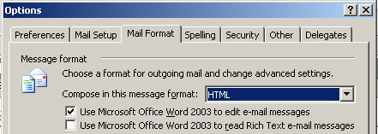
- Under Signature, click Signatures, and then click New.
- In the Enter a name for your new signature box, enter a name.
- Under Choose how to create your signature, select the option you want.
- Click Next.
- In the Signature text box, copy and paste the signature example, filling up necessary lines with your personal information.

- 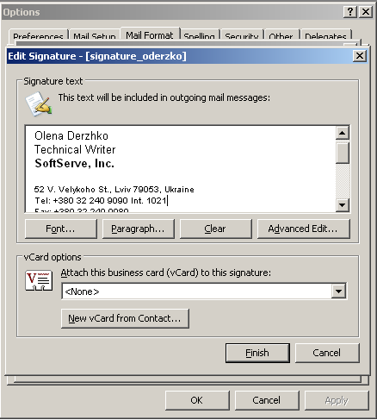
- Click Finish when you are done editing the new signature.
The examples of emails are provided in the end of the document.

Relevant Language to Use

Write concisely and be direct

Be direct and to the point in setting out for the reader the issues that you wish to address.
Don't use the excessive punctuation
You see lots of email messages with a dozen exclamation points at the end of a sentence for added emphasis. Remember, if something is important it should be reflected in your text.
Don't type in capitals
Online, writing in capitals means shouting. Regardless of your intention, people will react as if you meant to be aggressive.
Use abbreviations that are already common in the English language, such as 'FYI', 'ASAP' and 'BTW'
Abbreviation usage is quite uncertain with email. Some of the more common abbreviations are listed in the list below. However, only the following ones are commonly accepted and widely used in English language:
'FYI' (for your information), 'ASAP' (as soon as possible), 'BTW (by the way)', ‘IMHO’ (in my humble opinion), AKA (also known as), TBD (to be defined).
Beyond that, you run into the risk of confusing your recipient.
The abbreviations located in the table below are rarely used in business correspondence, so try to avoid using them, or write an explanation in brackets.
This | Means This
BCNU | be seeing you
EOD | end of a day
EOW | end of a weak
EOY | end of a year
FWIW | for what it's worth
ETA | estimated time of arrival
N/A | not applicable
OBO | or best offer
ROTFL | rolling on the floor laughing
RTFM | read the funny manual
TBC | to be considered
TNSTAAFL | there's no such thing as a free lunch
TTFN | ta ta for now
TTYL | talk to you later

Do not send or forward emails containing dishonorable, racist, sexist, obscene or otherwise offensive remarks

Writing or even forwarding just one potentially offensive remark, or comment especially concerning customer or partner can negatively impact business relationships. Use appropriate and politically correct language. For example:

Do not use expressions like Hi bro or Hello my black man brother or other things the recipient may take as offensive.

See examples on politically correct language below:

poormarginalizedstupid intellectually disadvantagedunable to deal with technical appliancestechnologically challenged

And examples of alternatives to sexist language:

postmanpostal agentair hostess flight attendantmanmadesynthetic
Try to be polite and always think before you mail.
When in doubt follow the main rules of email communication in order not get into an absurd situation.

Use English language in all emails regarding English speaking customers

When emailing internally use English language also. Take into account the possibility of email to be forwarded to the customer or another English-speaking person, so preserve proper email message structure and be polite when writing your emails.

Proofread - before sending reread the message

Take the time to make your message look professional. When you are sending a message that will be read by someone higher up on the chain of command (a superior or professor, for instance), or if you are about to mass-mail dozens or thousands of people, take an extra minute or two before you hit Send. Show a draft to a close associate, in order to see whether it actually makes sense.

Formatting Email Message
Keep your emails easy-to-read and well-written; it helps the reader stay focused on the content of the email instead of being distracted by poor structure, grammar, or spelling.
When sending emails, make sure your customer’s mail system is able to receive your mail in formatting you set.
Keep paragraphs short
Paragraphs should be no more than five or six lines long.
Watch font size
Avoid fonts that are smaller than 10 points or larger than 12 points (except in headlines or to embed details). Also, remember that writing in all capitals is considered shouting and is often perceived as aggressive and rude.
Use "white space"
Use white space — empty space on the screen — to separate paragraphs and areas of detail. The white space helps to ease the transition from one subject to another.
Use bullets and tables
Lists and tables help the reader identify the key points in a condensed format that is separate from the text.
But make sure the customer’s mail system will reflect the formatting properly, that is why it is better to answer the letter in the same format of the letter received. If you received the letter in HTML format, keep the same format when answering.
Use priority indicators
Take the advantage of using the importantindicator to let recipients know that you have sent them an important message.
A message flag can be used to mark the message and make it easy to scan the Inbox and find it again, either as a reminder for you or to catch a recipient's attention.

Use spell checking option when composing email message
It is strongly recommended to run a spell checker before sending an email.
You can make it automatic.
- From the main Microsoft Outlook window, on the Tools menu, click Options, and then click the Spelling tab.
- Select the options you want.
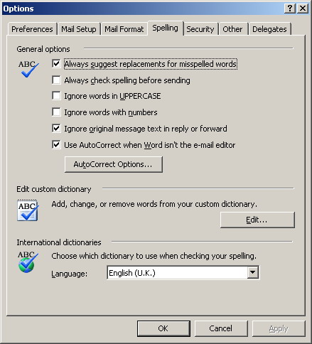
Using Spell Checking option you can also:
- edit custom dictionary, by adding, changing or removing words from it,
- choose required dictionary when checking your spelling and,
- use AutoCorrect option.
If you use MS Word to edit email messages, the spelling will be verified automatically for Rich Text and HTML formatted emails.
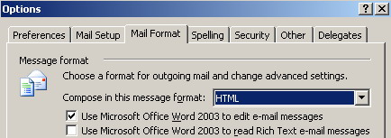

Sending Attachments with Care
Do not send unnecessary attachments. According to corporate standards it is allowed to send attachments in any format with size no more then 10 MB. The exe. files should be archived before sending, that is why make sure the recipient will be able to unzip the received mail. Try to use ZIP Archiver as the most common in the business world.
Types of attachment format carrying possible viruses might be blocked from receiving.

Configuring Your Mail Account
Using Microsoft Outlook, you can add several email accounts to a single Outlook user profile. For example, you can add a Microsoft Exchange Server account to handle your business email and then add an Internet email account, such as a POP3 account from your ISP, to handle your personal email. Properly configure the following data in your mail account.
- Type of account (Exchange Server, POP3, IMAP, HTTP, or other)
- Name of your incoming server and outgoing server
- Your user name (for example: Konstyantyn Myliv not just Kostya )
- Your email address (for example: someone@example.com)
- Your password

Examples of Emails
New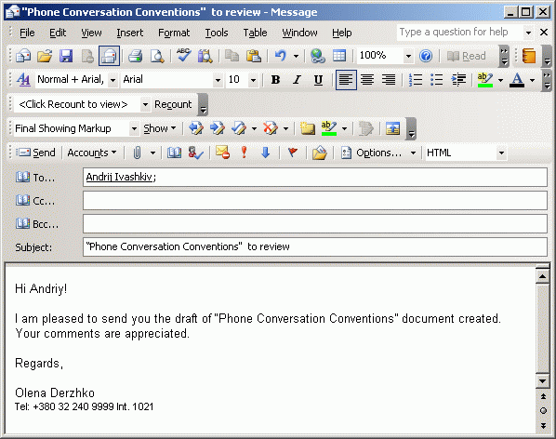

Replied 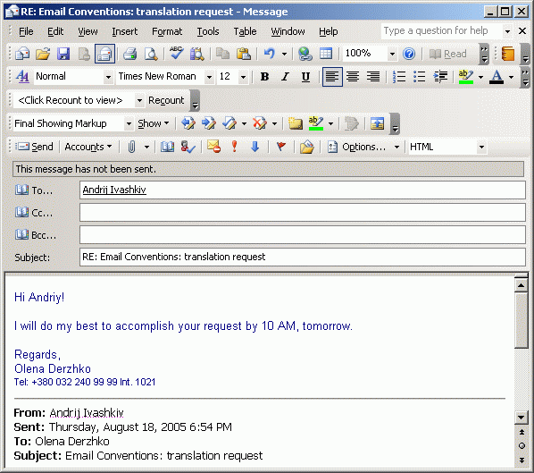

Forwarded 